Ex.No: 5a | DATA VISUALIZATION USING MATPLOTLIB

AIM:
To create and analyze various data visualizations such as Line Charts, Bar Charts, Pie Charts, Histograms, Scatter Plots, and Box Plots using Matplotlib for effective data interpretation.

ALGORITHM:
Step 1: Start.
Step 2: Import the required libraries:
- pandas
- matplotlib.pyplot
- seaborn (optional)
Step 3: Create the monthly sales dataset or load it from a CSV file.
Step 4: Store the data in a Pandas DataFrame.
Step 5: Display the dataset to verify that it has loaded correctly.
Step 6: Create the required visualizations:
- Line Plot
- Bar Chart
- Scatter Plot
- Histogram
- Box Plot
- Pie Chart
Step 7: Add appropriate:
- Title
- X-axis label
- Y-axis label
- Legend (if needed)
Step 8: Display each graph using plt.show().
Step 9: Analyze the visualizations to identify:
- Sales trends
- Highest sales month
- Lowest sales month
- Distribution of sales values
Program;
import matplotlib.pyplot as plt
months = ["Jan","Feb","Mar","Apr","May","Jun"]
sales = [120,150,180,170,220,250]
plt.plot(months,sales)
plt.title("Monthly Sales")
plt.xlabel("Months")
plt.ylabel("Sales")
plt.show()
Bar chart:
plt.bar(months,sales)
plt.title("Monthly Sales")
plt.xlabel("Months")
plt.ylabel("Sales")
plt.show()

pie Chart:
departments = ["HR","IT","Finance","Sales"]
employees = [25,40,20,15]
plt.pie(employees,
labels=departments,
autopct='%1.1f%%')
plt.show()

Box plot:
salary=[25000,27000,30000,
32000,35000,
40000,150000]
plt.boxplot(salary)
plt.show()
line chart:
months=["Jan","Feb","Mar","Apr"]
sales=[120,150,180,200]
profit=[20,30,40,50]
plt.plot(months,sales,label="Sales")
plt.plot(months,profit,label="Profit")
plt.legend()
plt.show()

OUTPUT:
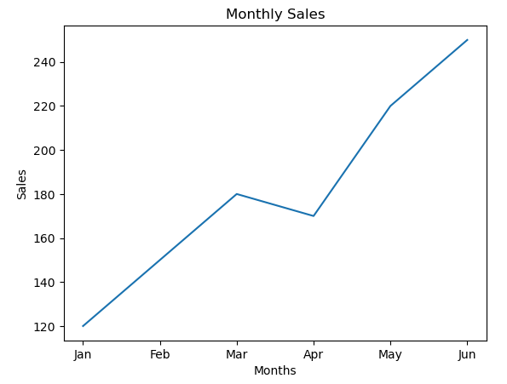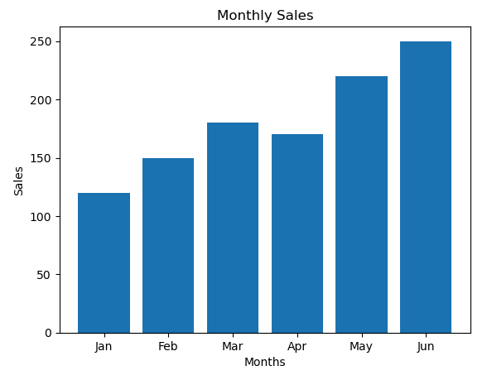
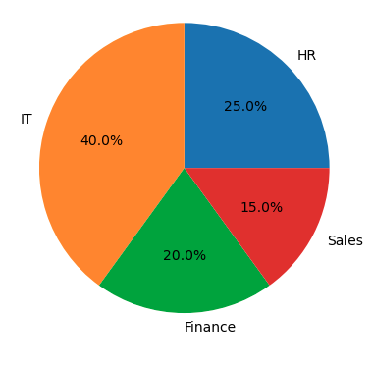
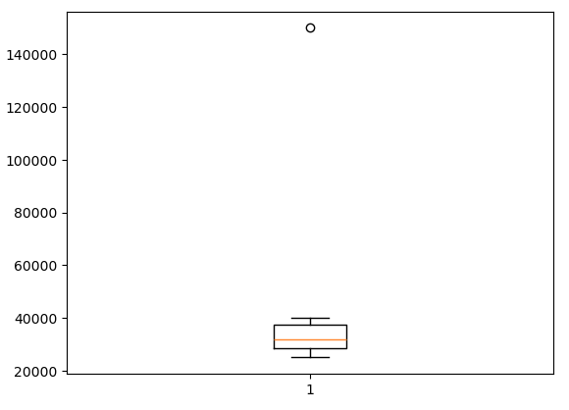
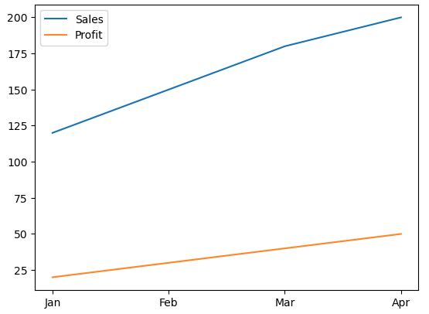

RESULT:
Thus, various visualization techniques such as Line Charts, Bar Charts, Pie Charts, Histograms, Scatter Plots, and Box Plots were successfully created using Matplotlib. The graphical representations helped in understanding trends, distributions, comparisons, and relationships within the dataset.

